CLASS DESIGN
- Class “OrderController”
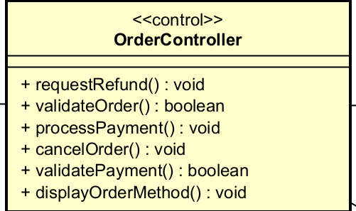

Attribute
Operation
# | Name | Return type | Description (purpose)
1 | requestRefund | void | Request a refund to turn back money and give back the product to shop
2 | validateOrder | bool | check the right of Order’date
3 | processPayment | void | process to Payment (VNPayInterface and VNPay)
4 | cancelOrder | void | Request to cancel the order
5 | validatePayment | bool | check the right of payment’s date
6 | displayOrderMethod | void | display the payment method (now it’s just via VNPay)

Parameter:
Exception:
- PaymentException: if responded with error that transaction is failed

State None
Method
- getExpirationDate: given the String “date” representing the expiration date in the format “”mm/yy”, this method convert it into the required format “mmyy”. The algorithm is illustrated as follows.
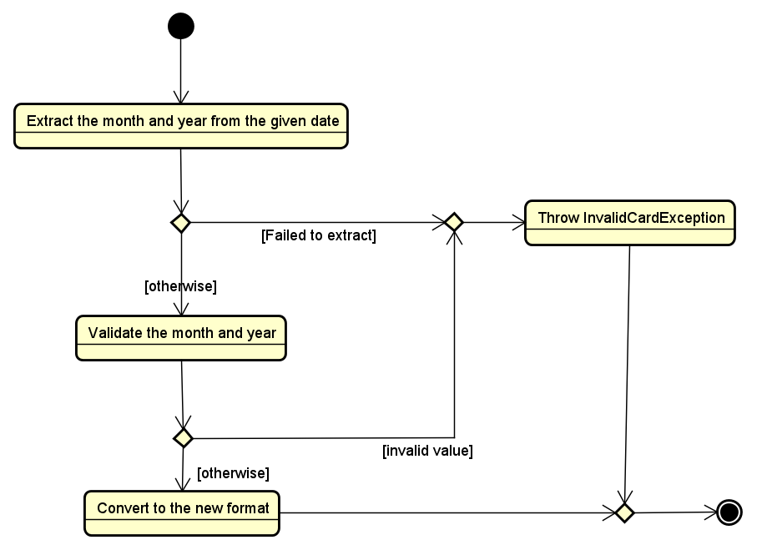

- Class “TransactionInfo”
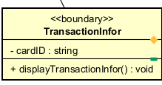
Attribute
# | Name | Data type | Default value | Description
1 | cardID | Card | NULL | Represent the card used for payment

Operation
# | Name | Return type | Description (purpose)
1 | displayTransactionInfor | void | Display the Transaction Information
Parameter: None
Exception: None
Method None
State None

- Class “CancellingConfirmScreen”

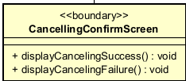

Attribute

Operation
# | Name | Return type | Description (purpose)
1 | displayCancelingSuccess | void | Display the Cancelation is success if the VNPay accept to cancel
2 | displayCancelingFailure | void | Display the Cancelation is fail if the VNPay doesn’t accept

Parameter:
Exception:
- CancelingException: if responded with error that canceling request is failed

State None
Method None

- Class “PaymentConfirmScreen”
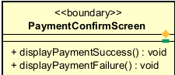

Attribute
Operation
# | Name | Return type | Description (purpose)
1 | displayPaymentSuccess | void | Return success if the payment is accepted
2 | displayPaymentFailure | void | Return fail if the payment is not accepted

Parameter: None
Exception: PaymentException: return fail if the payment is currently not being considered
Method None
State None

- Class “VNPayInterface”

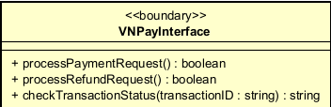

Attribute
Operation
# | Name | Return type | Description (purpose)
1 | processPaymentRequest | bool | send the request payment to VNPay
2 | processRefundRequest | bool | send the request to refund to VNPay
3 | checkTransactionStatus | string | check the transaction’s status is acceptable or not

Parameter:
Exception: None
Method None
State None

- Class “VNPay”

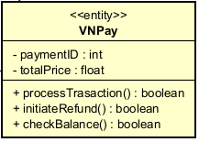

Attribute
# | Name | Return type | Description (purpose)
1 | paymentID | int | the ID of each payment
2 | totalPrice | float | amount of price of that payment

Operation
# | Name | Return type | Description (purpose)
1 | processTransaction | boolean | process to transaction
2 | initiateRefund | boolean | process to refund
3 | checkBalance | boolean | check the balance of user is enough or not

Parameter:
- totalPrice: total amount that VNPay will deduct from customer’s card
- paymentID: identify the payment
Exception:
- VNPayException: if responded with a pre-defined error code
- UnrecognizeException: if responded with an unknown error code or something goes wrong
- BalanceNotEnought: Return Fail Payment if the user’s balance is not enought

Method None
State None

- Class “OrderScreen”

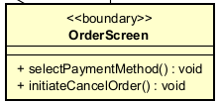

Attribute
Operation
# | Name | Return type | Description (purpose)
1 | selectPaymentMethod | void | select the method to pay (currently just VNPay)
2 | InitiateCancelOrder | void | process to canceling order

Parameter:
- user’s cardID: cardID of user used to payment
- reason: reason for cancelation
Exception: None
Method None
State None

- Class “Order”
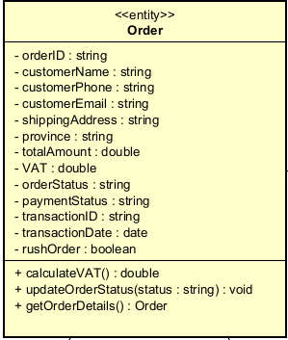
Attribute
# | Name | Return type | Description (purpose)
1 | orderID | string | ID of Order
2 | customerName | string
3 | customerPhone | string
4 | customerEmail | string
5 | shippingAddress | string
6 | province | string
7 | VAT | double | to calculate with totalAmount
8 | orderStatus | string
9 | paymentStatus | string
10 | transactionID | string
11 | transactionDate | date
12 | rushOrder | boolean | rush order or not

Operation
# | Name | Return type | Description (purpose)
1 | calculateVAT | double | calculate VAT and totalAmout = VAT value + product value
2 | updateOrderStatus | void | Update the OrderStatus
3 | getOrderDetails | Order | Display the detail of order
Parameter none
Method none
State none
- Class “RefundInfor”
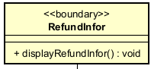
Attribute none
Operation
# | Name | Return type | Description (purpose)
1 | displayRefundInfor | void | display Refund Infor if all step above are passed
Parameter
- processRefundRequest is true
Exception : RefundException: if these step above (related to Refund) is not accepted.
Method none
State none
- Class “OrderHistory”
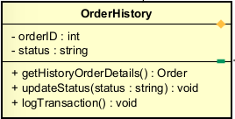
Attribute
# | Name | Return type | Description (purpose)
1 | orderID | int
2 | status | string | status of order (done/ shipping or cancelled)

Operation
# | Name | Return type | Description (purpose)
1 | getHistoryOrderDetails | Order | Display the Details of history Order
2 | updateStatus | void | update the status of order to Order
3 | logTransaction | void
Parameter
- Order that user wants to see detail history
Method none
State none

